Alliance School of Advanced Computing

Course Name: Graph Analytics
Course Code: E1ITC302
Assignment No: 3

Name of the Student: Mahi Kala

Registration Number: 2411021060486

A. Title of The Problem: Floyd: City of Blinding Lights
B. Problem Statement in details:
Given a directed weighted graph containing N nodes and M edges, the task is to find the shortest distance between pairs of nodes.
Each edge contains:
- Starting node
- Ending node
- Distance/weight
For each query, the shortest distance between the given source and destination nodes must be found.
If there is no path between the two nodes, the output should be -1.
The distance from a node to itself is 0.
If multiple edges exist between the same pair of nodes, the last given edge is considered.
For example:
Input:
4 5
1 2 5
1 4 24
2 4 6
3 4 4
3 2 7
3
1 2
3 1
1 4
Output:
5
-1
11
The shortest path from 1 to 4 is:
1 → 2 → 4
with total distance:
5 + 6 = 11
Therefore, the output is 11.

C. HackerRank/Leetcode Link of the problem (If applicable):
https://www.hackerrank.com/challenges/ctci-connected-cell-in-a-grid/problem
D. Student’s Github link of report and code upload, along with the readme file:
https://github.com/mahikala2312/Graph-Analytics/blob/main/assignment%203.py
E. Solution Steps/Algorithm:
- Read the number of nodes and edges in the graph.
- Create a distance matrix to store the shortest distances between every pair of nodes.
- Initialize all distances to infinity.
- Set the distance from every node to itself as 0.
- Read all edges and store their weights in the distance matrix.
- Use the Floyd-Warshall algorithm to find the shortest paths.
- Consider each node as an intermediate node.
- For every pair of nodes, check whether going through the intermediate node gives a shorter path.
- Update the distance if a shorter path is found.
- Read each query containing a source and destination.
- If the distance is infinity, print -1.
- Otherwise, print the shortest distance.

Time Complexity:
O(N³)

Space Complexity:
O(N²)

F. Code developed:
import sys

input = sys.stdin.buffer.readline

n, m = map(int, input().split())

INF = 10**18

dist = [[INF] * n for _ in range(n)]

for i in range(n):
dist[i][i] = 0

for _ in range(m):
u, v, w = map(int, input().split())
u -= 1
v -= 1
dist[u][v] = w

for k in range(n):
for i in range(n):
if dist[i][k] == INF:
continue

for j in range(n):
new_dist = dist[i][k] + dist[k][j]

if new_dist < dist[i][j]:
dist[i][j] = new_dist

q = int(input())

for _ in range(q):
u, v = map(int, input().split())

distance = dist[u - 1][v - 1]

if distance == INF:
print(-1)
else:
print(distance)
G. HackerRank test case passed Screenshot or Output screenshot (Mandatory):
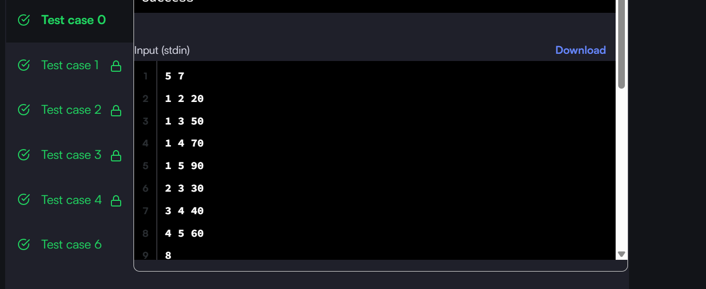

H. Observation:
The problem can be efficiently solved using the Floyd-Warshall algorithm.
The important observation is that the algorithm considers every node as an intermediate node and checks whether passing through that node produces a shorter path between two other nodes.
The distance matrix is updated whenever a shorter path is found.
For the given example, the direct distance from node 1 to 4 is 24, but a shorter path exists through node 2:
1 → 2 → 4
with distance:
5 + 6 = 11
Therefore, the shortest distance is 11.
If no path exists between two nodes, -1 is displayed.

